**Nick Weibler Assignment 6**

1. The company will be increasing its’ store size for the holiday season. We will need more employees to work in preparation for the increase so we need to contact our part time employees to ask if they will be willing to work more hours.

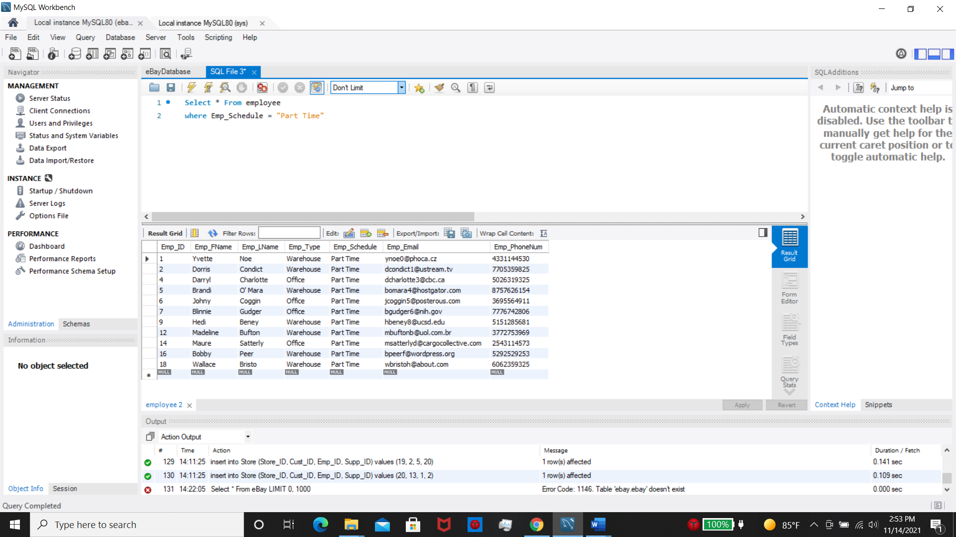

1. The company wants to know which customer has spent more than $450 in the store and their contact information so they can send loyalty coupons out.

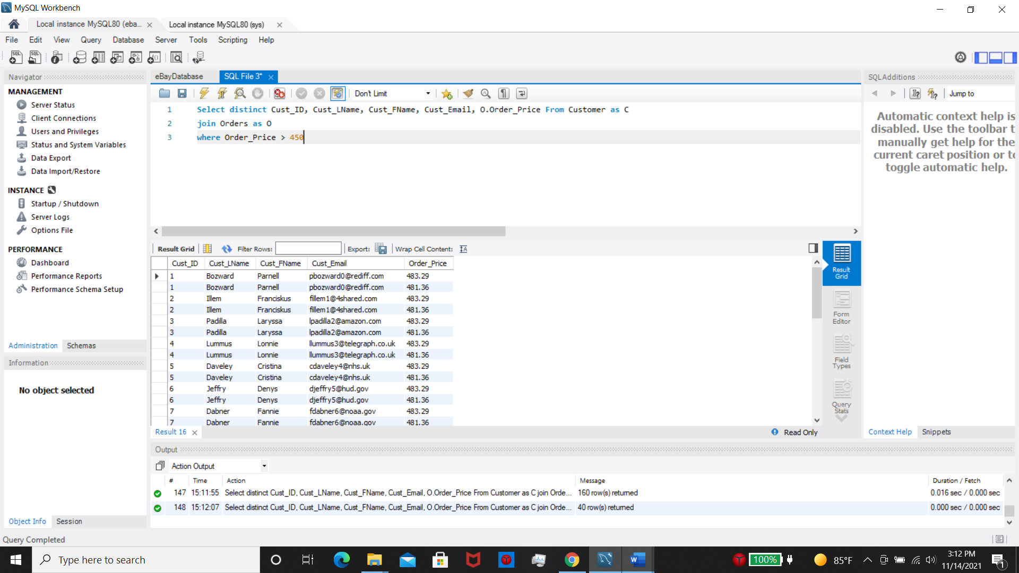

1. The company wants to figure out which supplier we are spending the most money on per shipment and what categories those items are in.

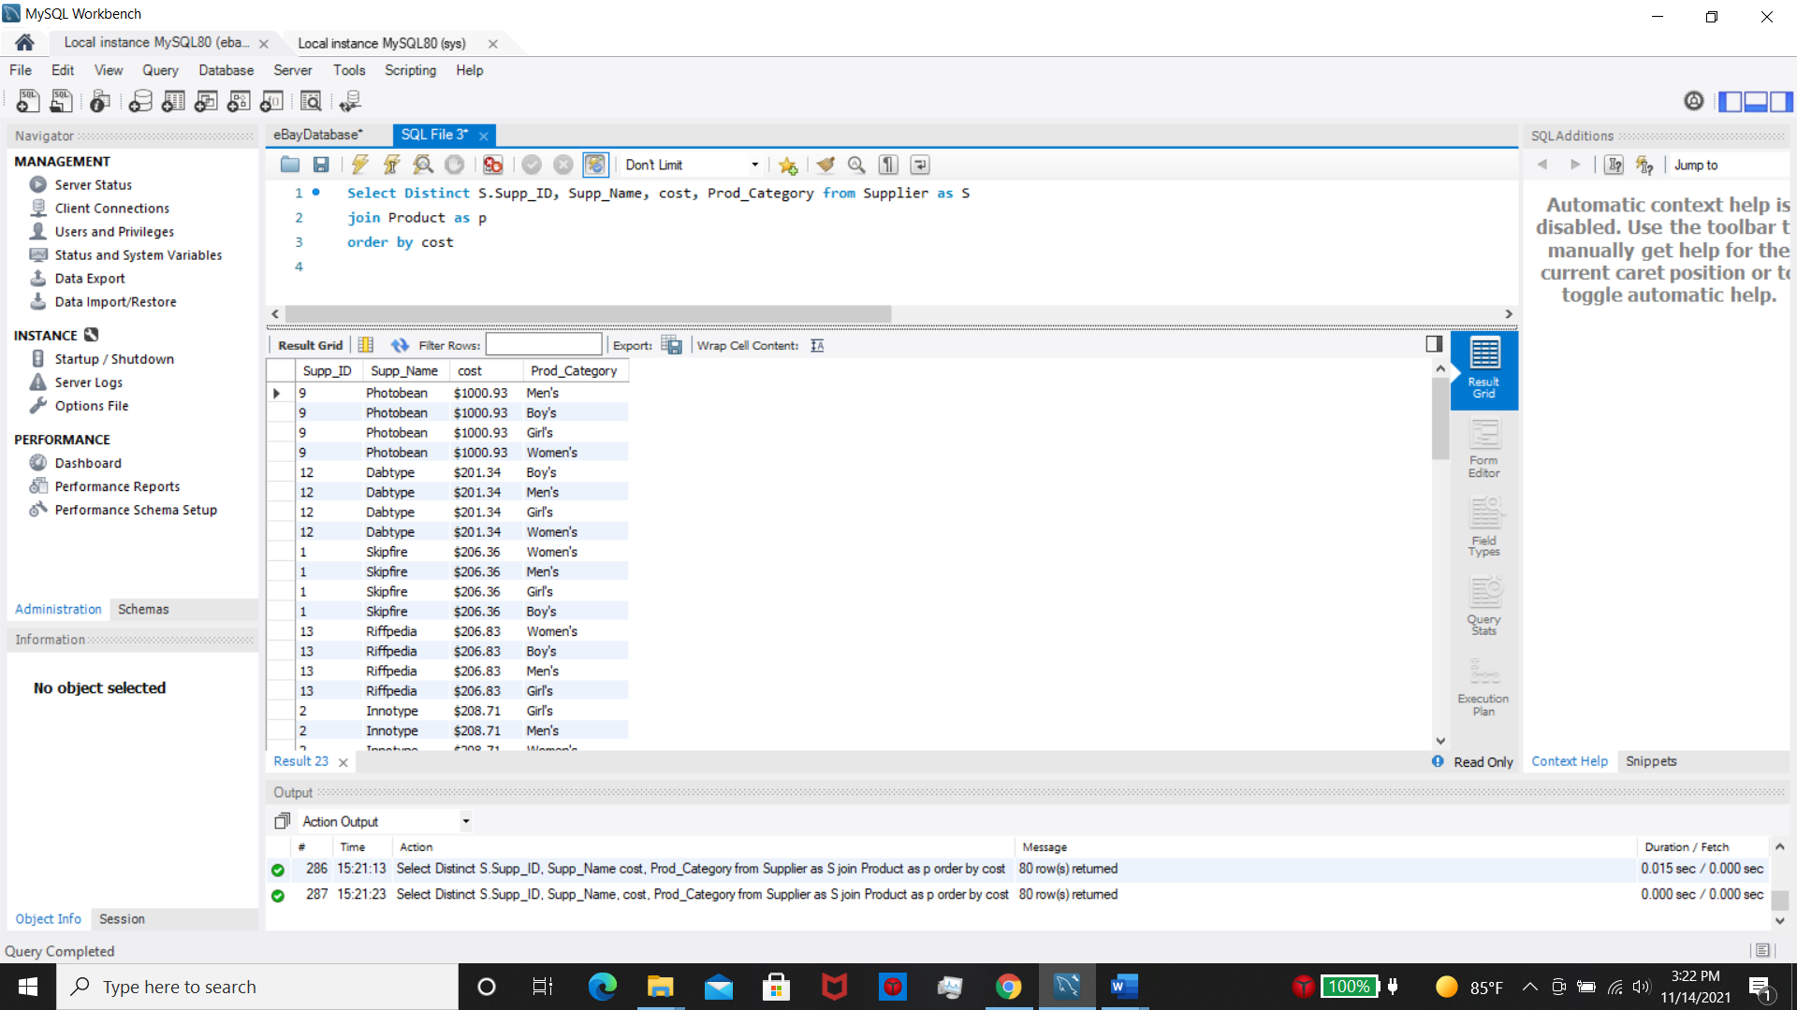

1. The company is receiving an extra shipment of goods this weekend and we will need to call the warehouse crew in to work, but we only want part time workers so we won’t have to pay overtime.

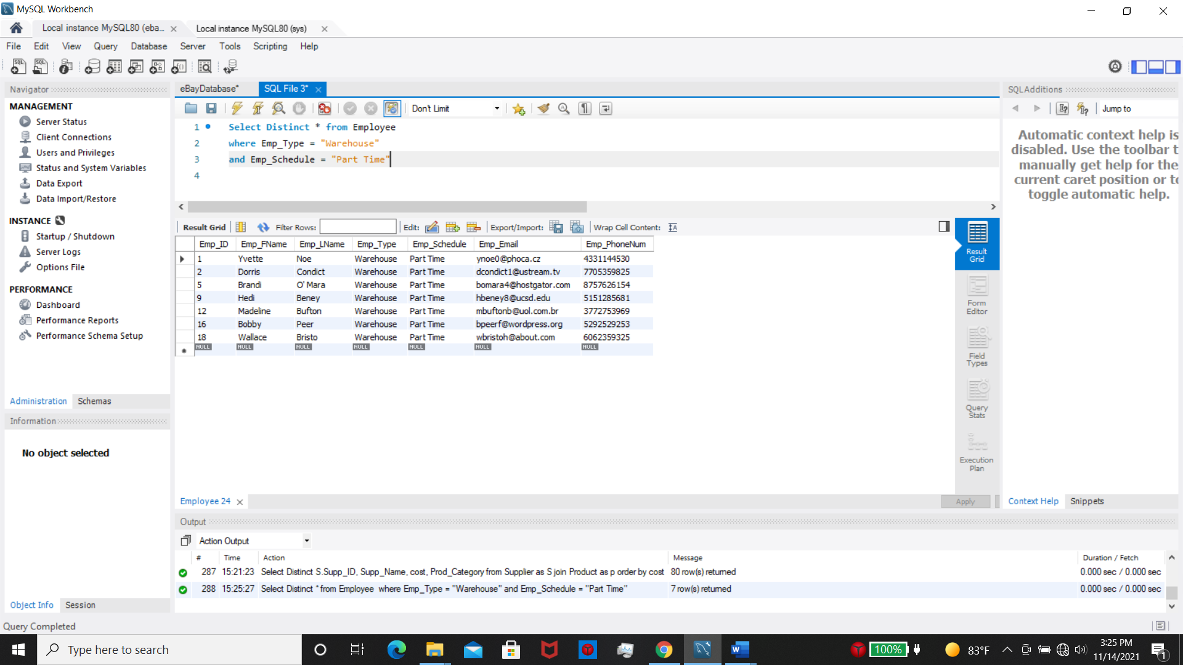

1. One of our warehouse employees forgot to fill out their name on the inventory sheet but luckily wrote down their employee ID: 15. We need to locate the employee’s name so we can notify them and let them know.

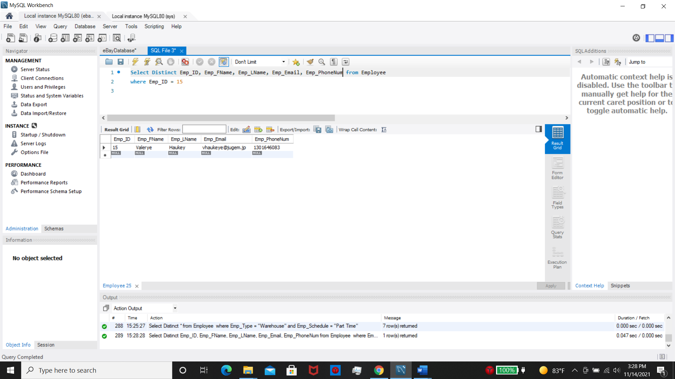

1. We need to find items in the store that have a low quantity ( under 100 ) so we can contact the supplier and order more.

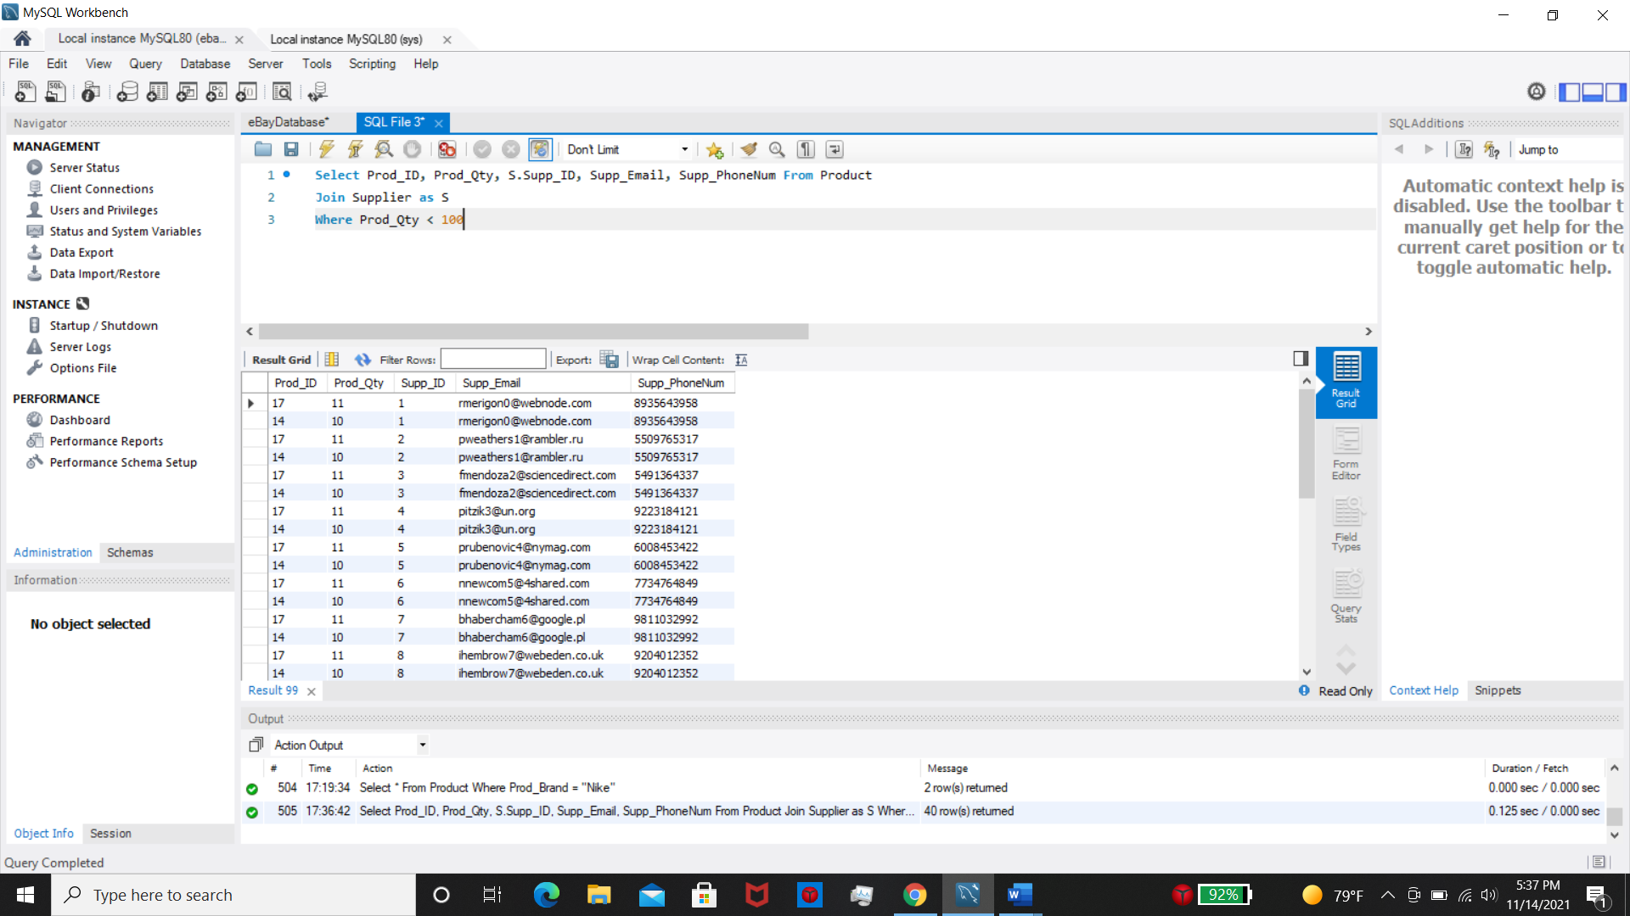

1. The company wants to know what our top 10 most expensive items are so we can create a marketing campaign that brings in more revenue.

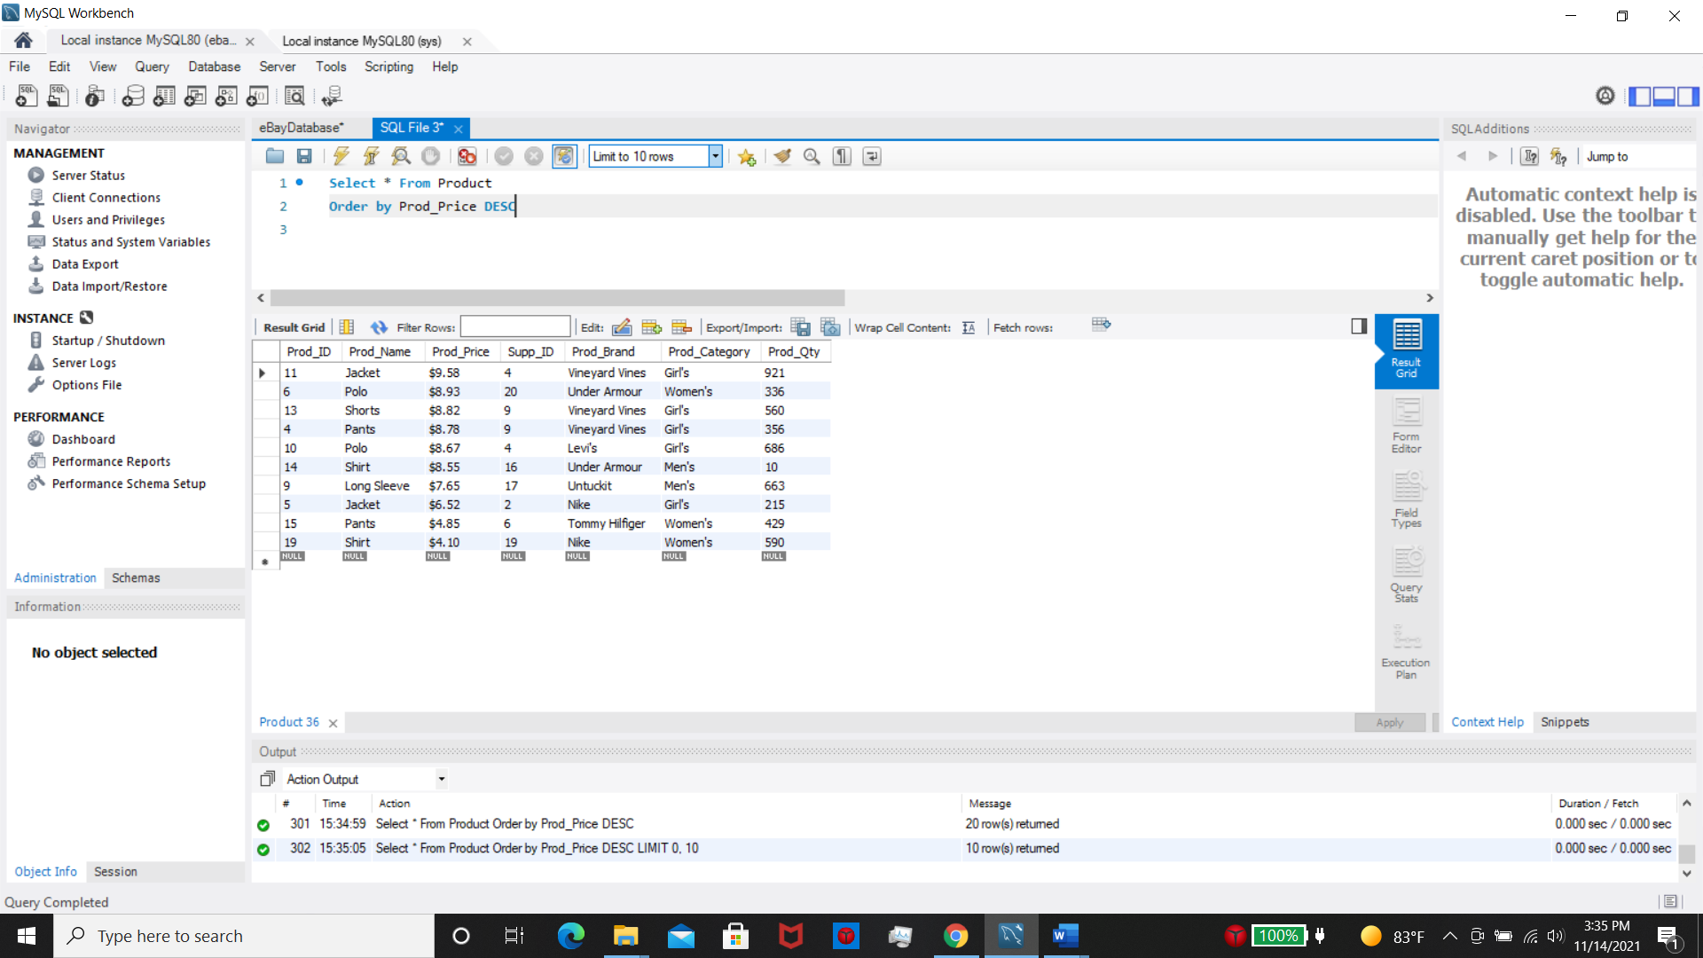

1. A customer with the username djeffry5 emailed the company saying he placed a bulk order for Nike shirts and they had backwards logos. We need to contact the supplier where they came from and let them know they sent us counterfeit items.

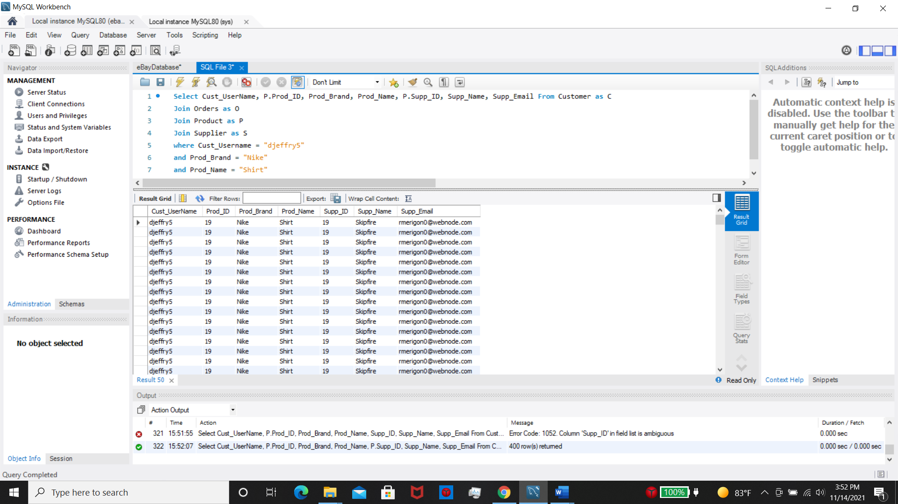

1. A customer with the last name “Dabner” contacted our customer support saying that their order they placed on 10/7/21 at 2:12 PM never arrived. We need to find out what is going on with that package.

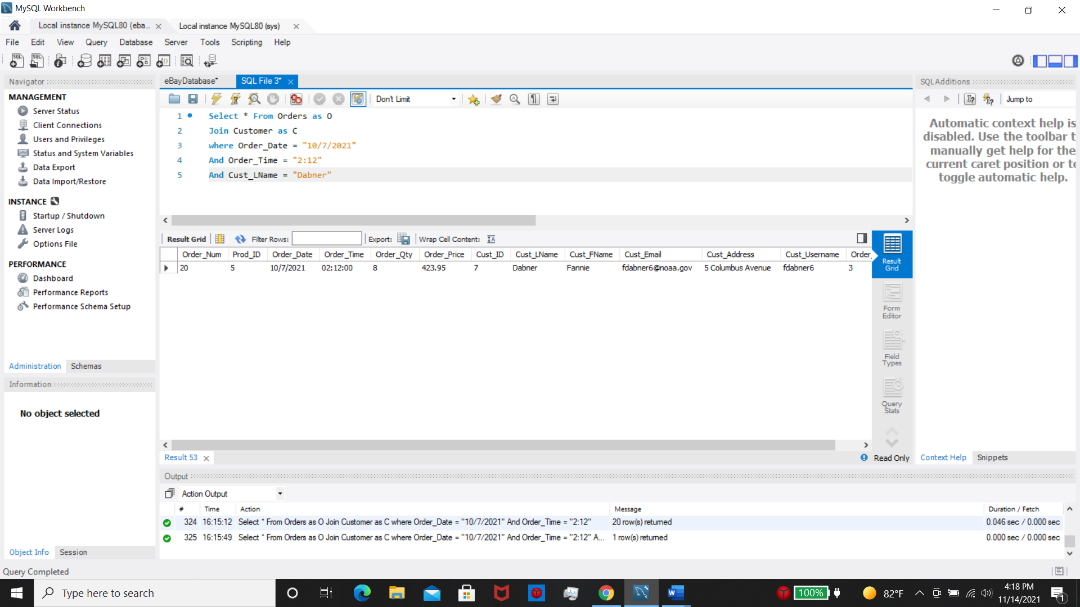

1. One of our suppliers, Shuffletag Co. is raising their cost by 30% due to supply chain issues and uncontrolled inflation due to Covid-19. We need to check how much we are paying them currently to see if we need to drop them as a supplier.

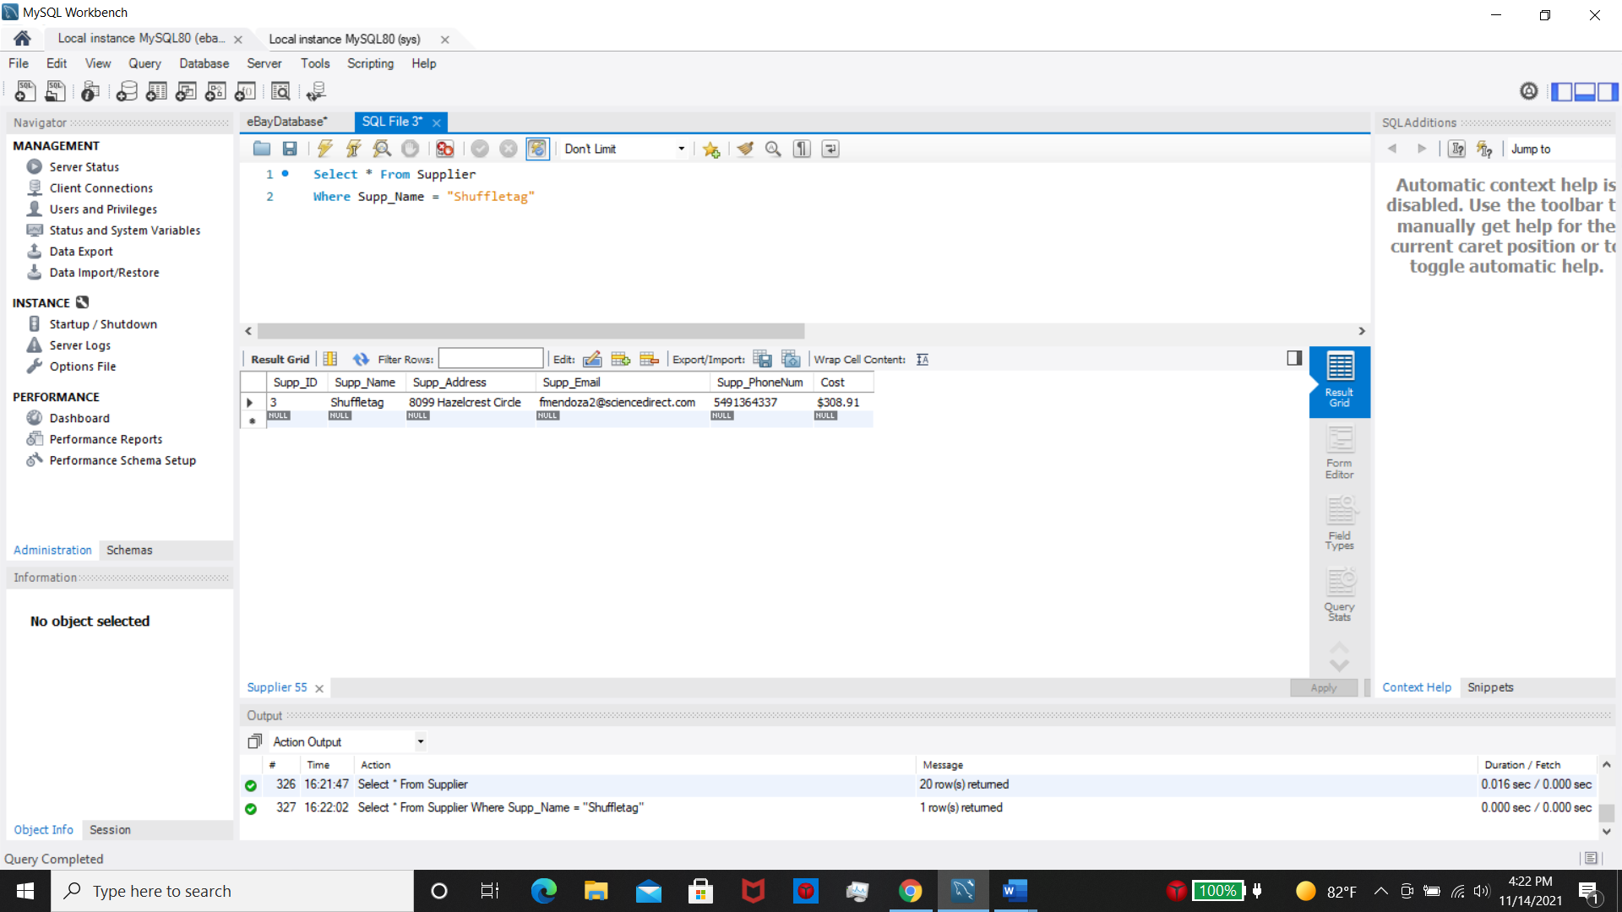

1. The company wants to run a sale on items that we have over 500 on hand to make room for new inventory UNLESS it’s our favorite brand Nike.

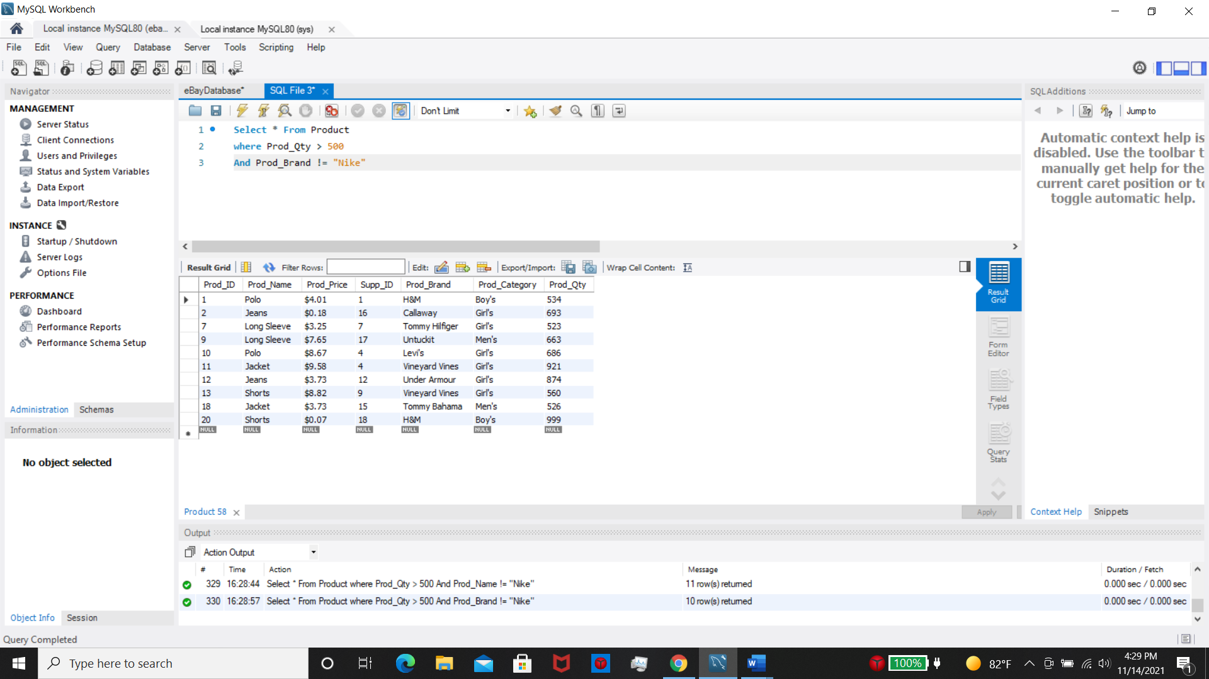

1. One of our customers named Parnell sent an email saying his is local and would like to pick up his order from the warehouse. The company said that will be fine if he is within 15 miles and can give us an accurate pick up time. We need to check his address on Maps to make sure he is actually local.

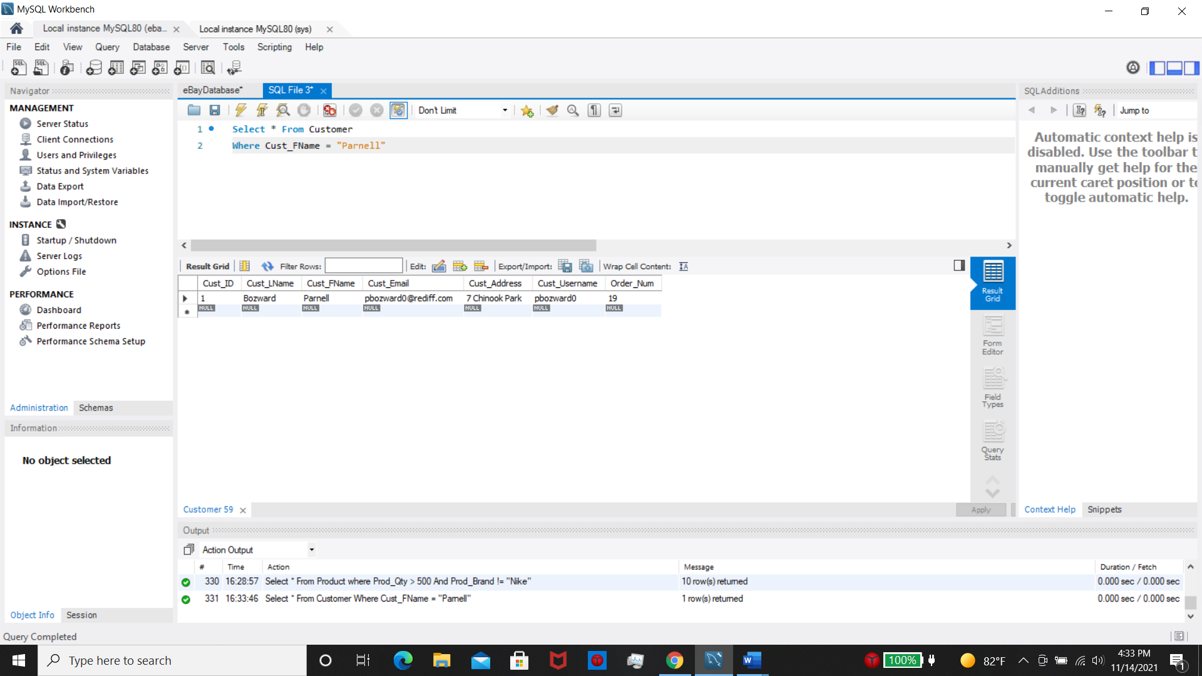

1. The company held a raffle and is rewarding customers who have placed orders with item quantity’s over 4. Every Item over 4 in an order will equate to one raffle ticket. The company wants a list of all the customers that meets this criteria.

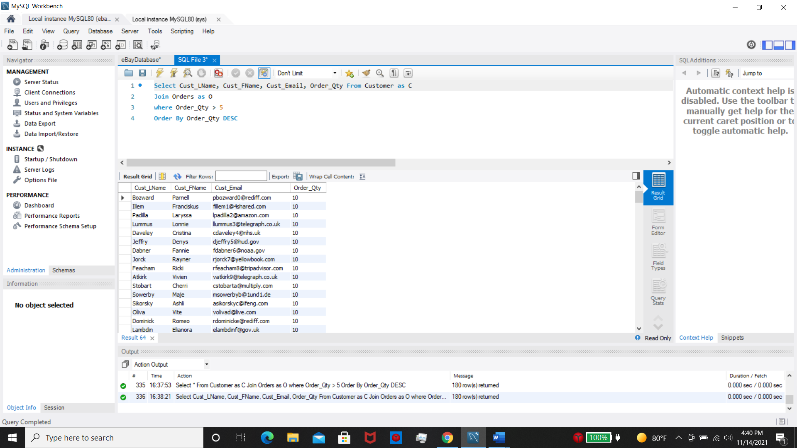

1. The office is holding an all hands meeting and wants a list of all the employees who need to be present.

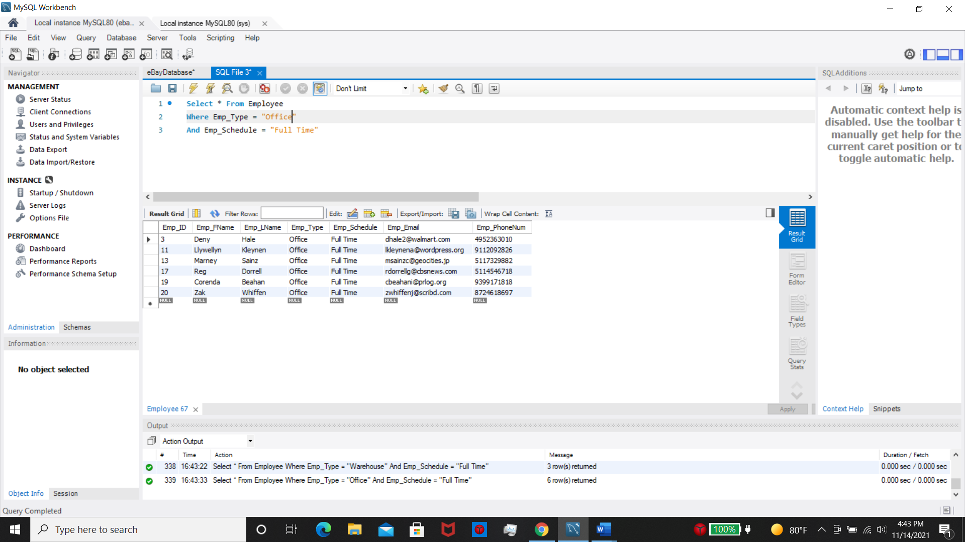

1. One of our suppliers dropped off a package outside our unit this weekend and they parked just outside of the security cameras. The camera only picked up an “S” on the truck. We need to contact all our suppliers who start with S and ask if it was them who left the package.

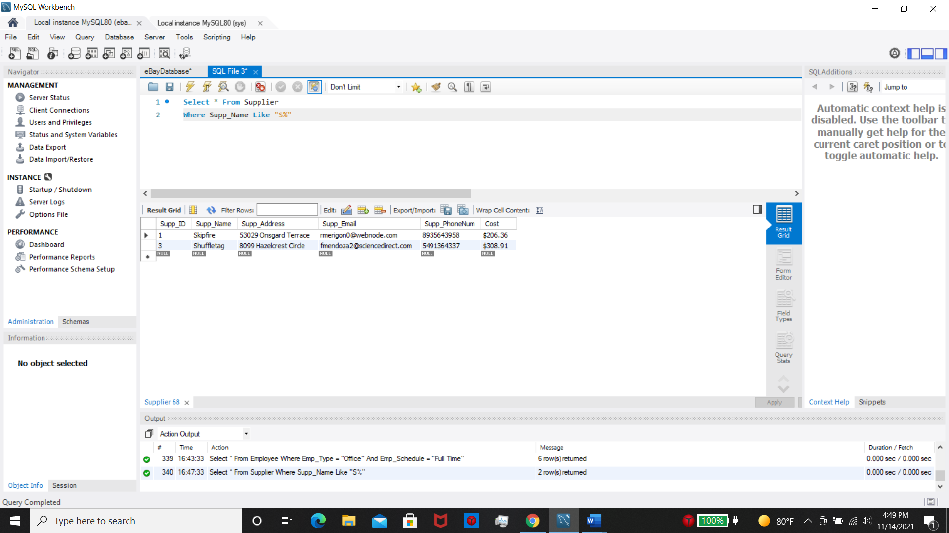

1. The company wants to know all the polos we have in our store that are for Boys.

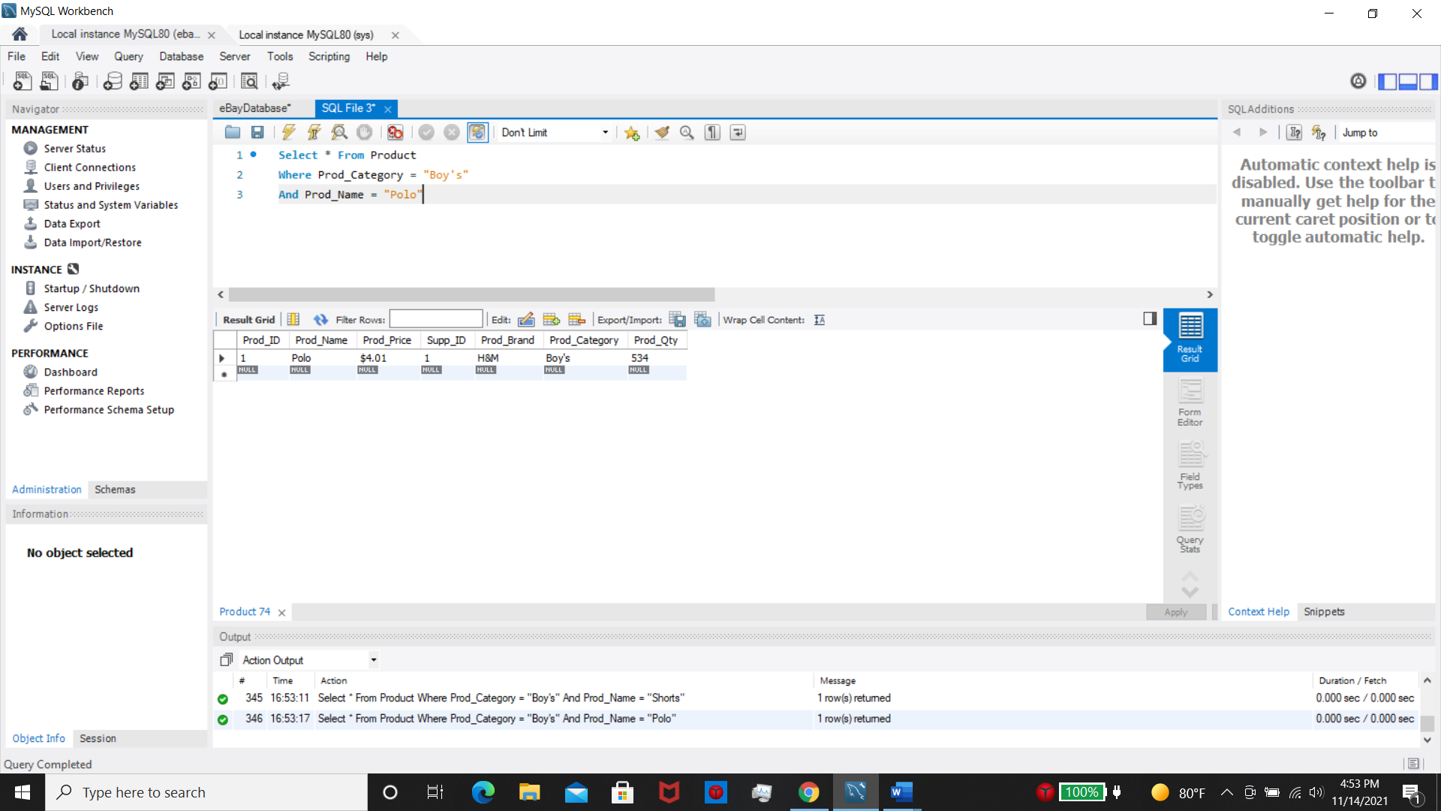

1. The company isn’t making enough money to continue receiving shipments from all our suppliers. The company wants to drop 3 of our smallest suppliers to save some money.

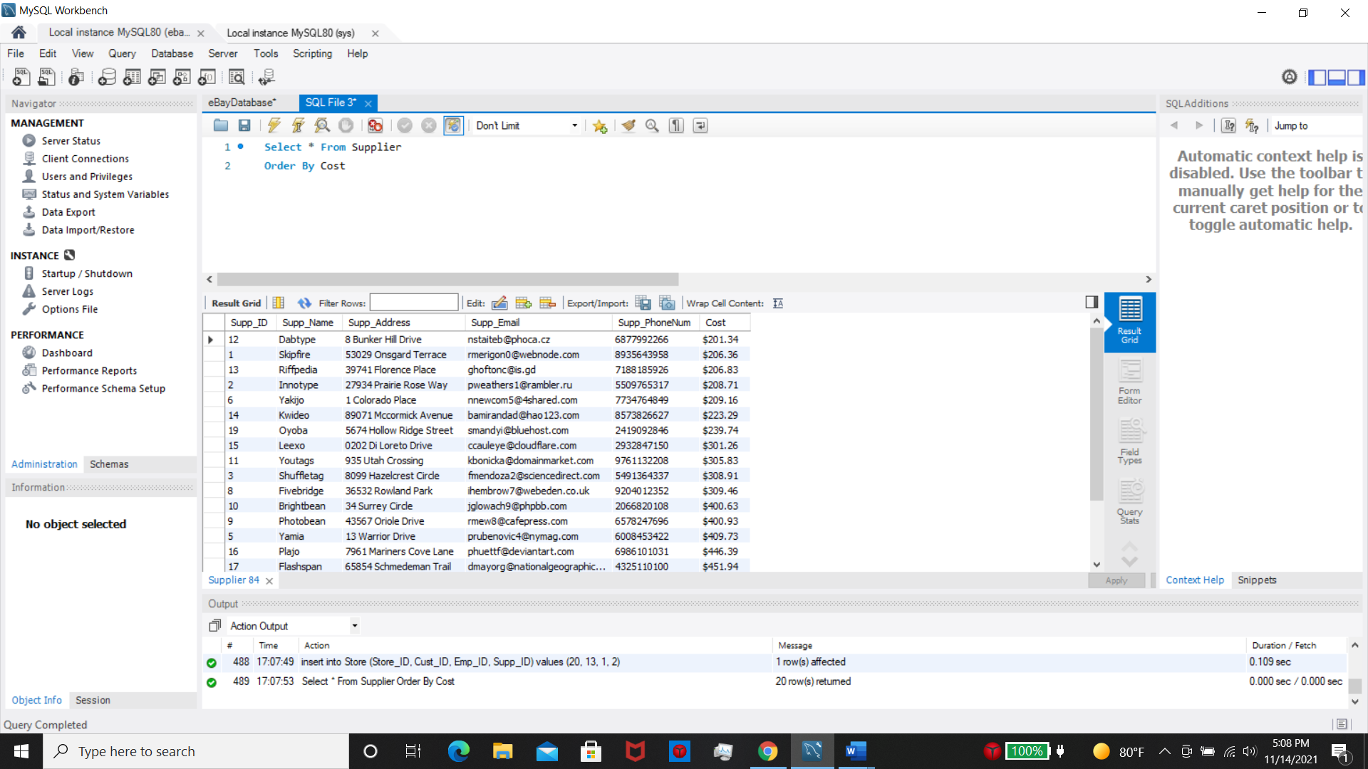

1. Dropping some of our suppliers didn’t help save enough money and now the company wants to let go of 3 workers. The company only wants to fire part time workers from the warehouse. We need a list of those employees.

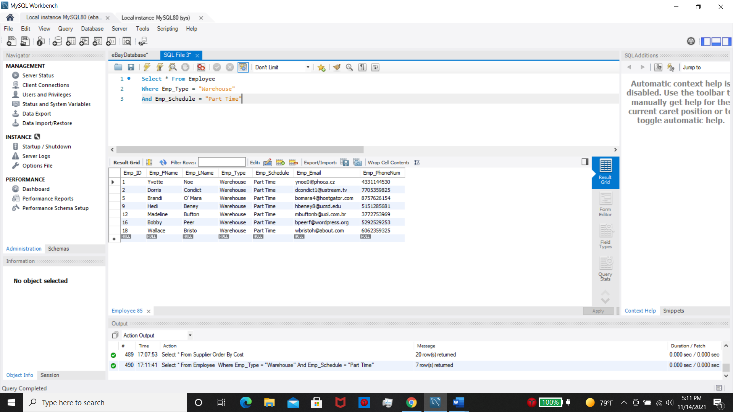

1. The company wants to raise the price of all the store’s cheapest items. Any item that is less than $3.99 will be subject to a 15% increase in price.

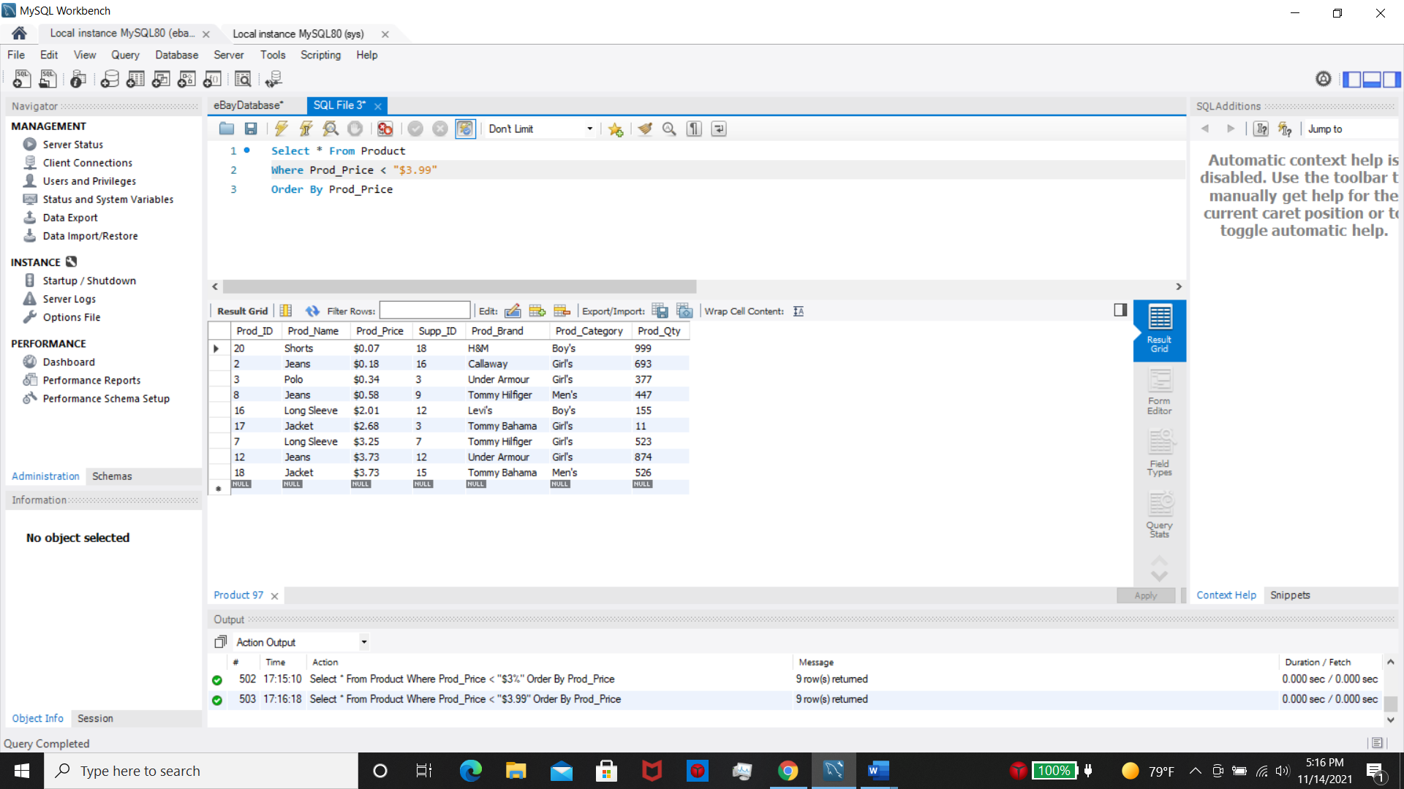

1. The company was contacted by Nike in a very angry email. Nike stated they are no longer allowed to sell their brand or they will take legal action. The company needs to find all the products that are Nike brand and remove them from the store.

